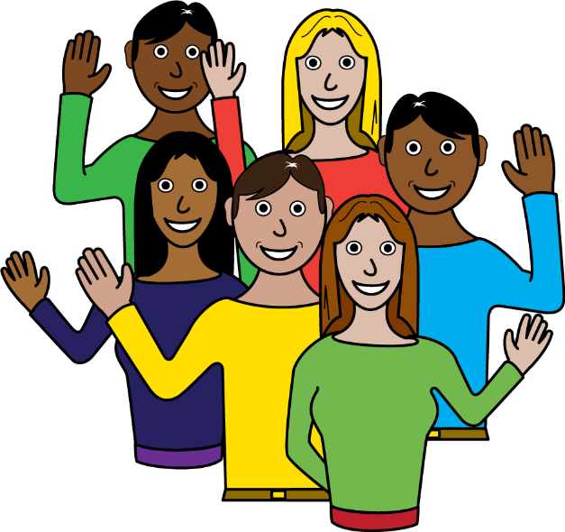 | Hello!  We are Together (Scottish Alliance for Children’s Rights).  We are a charity that helps make things better for children.  Welcome to our 2022 report!
 | This report looks at how well children’s human rights are being protected in Scotland.
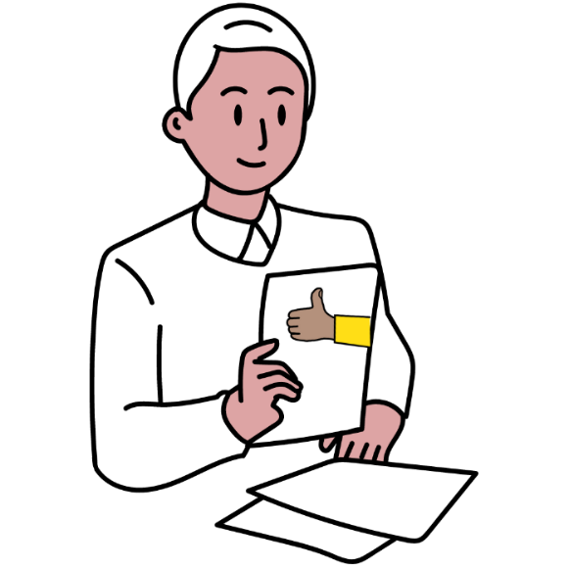 | This report looks at what adults can do better for children.

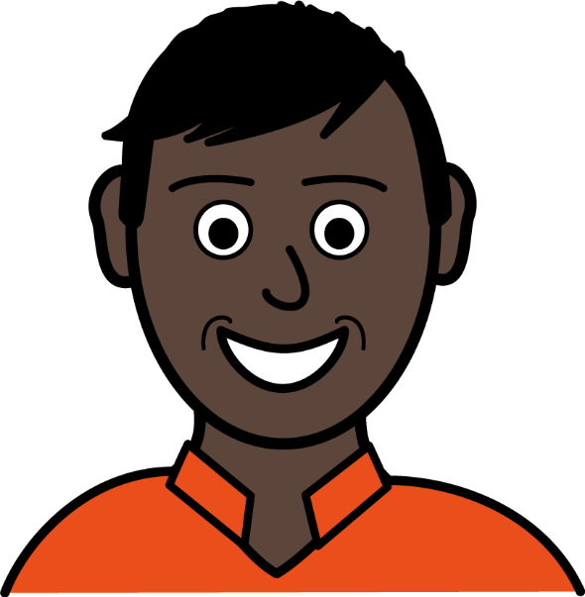 | What are children’s rights?  Every child is born with human rights. These are things every child needs to grow up happy, healthy and safe.  Here are some examples of children’s rights:
 | - The right to play
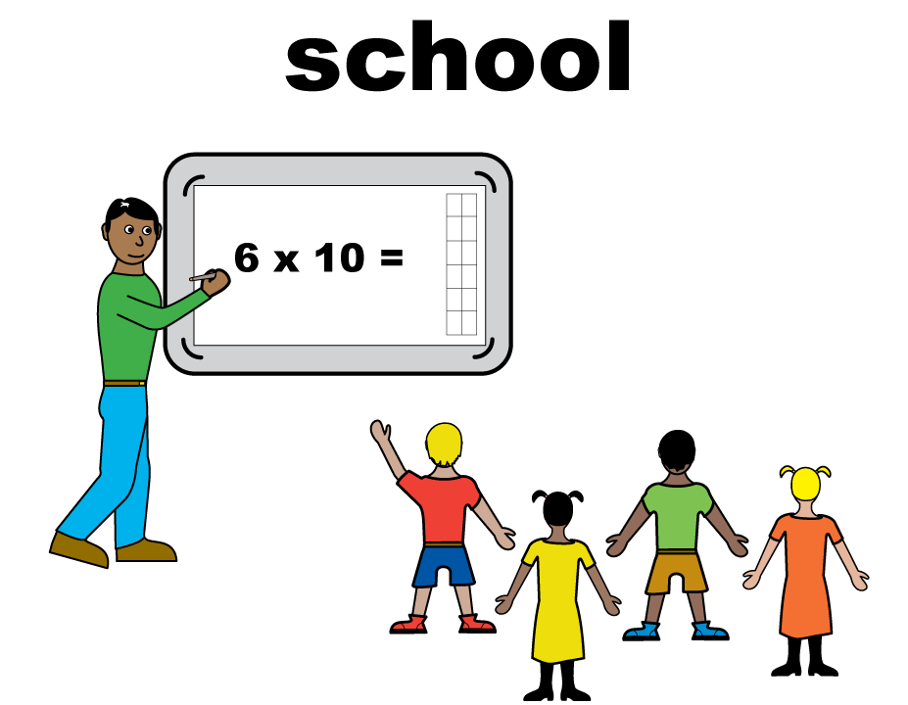 | - The right to learn and go to school
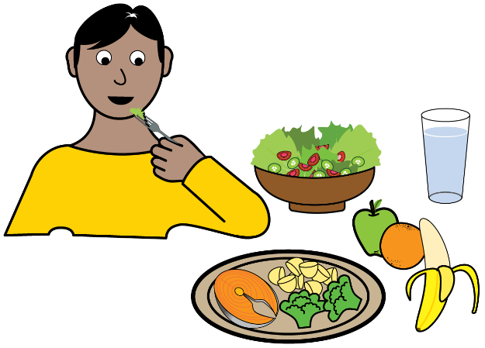 | - The right to eat healthy food
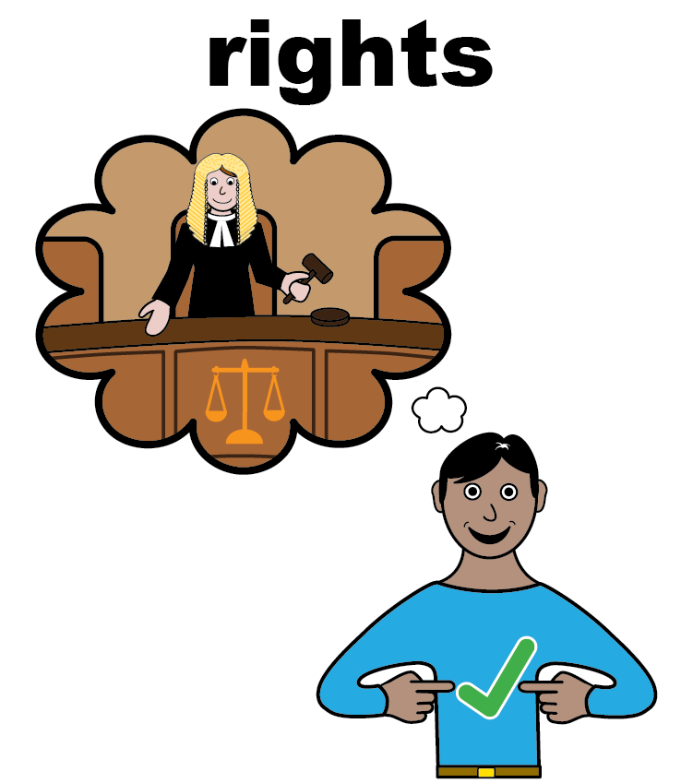 | Children’s rights and the law  The Scottish Government wants to make children’s rights part of the law.
To put children’s rights into law, Scottish Government wrote a bill.

A bill is a document that could become a law.
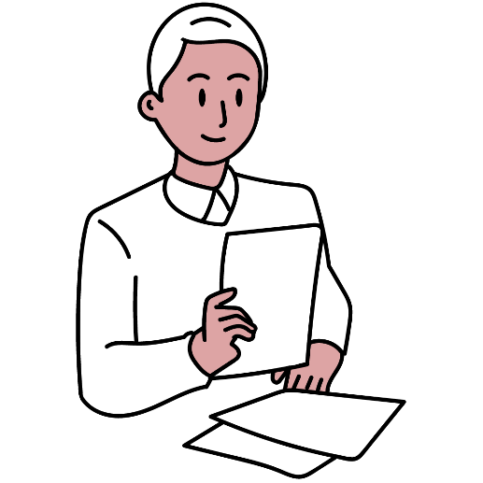 | This report will help adults get ready for this new law.  It says what adults should be doing:
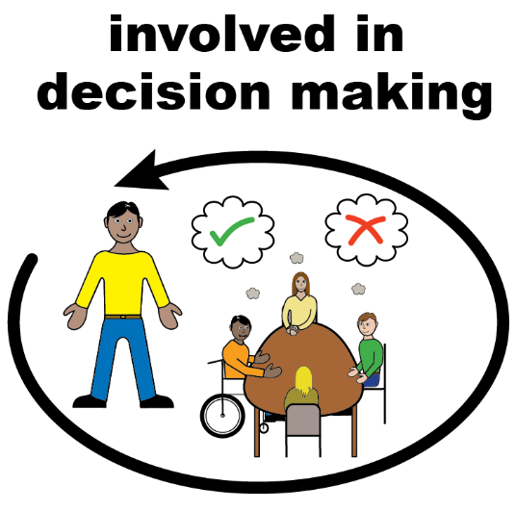 | Adults should include children in decisions  Children should have a say in decisions and be listened to by adults.
 | An example of children being involved in decisions is helping your school choose what is on the lunch menu.
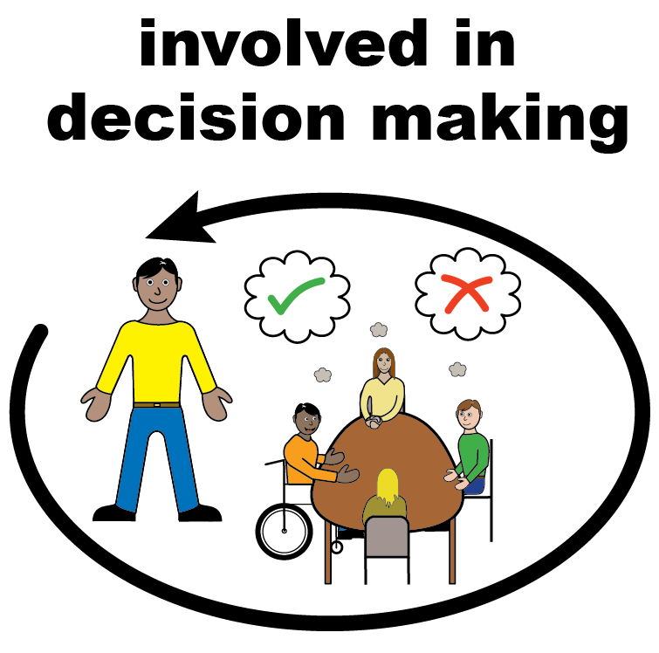 | Here are some ways adults can make sure children are included in all decisions that affect them:
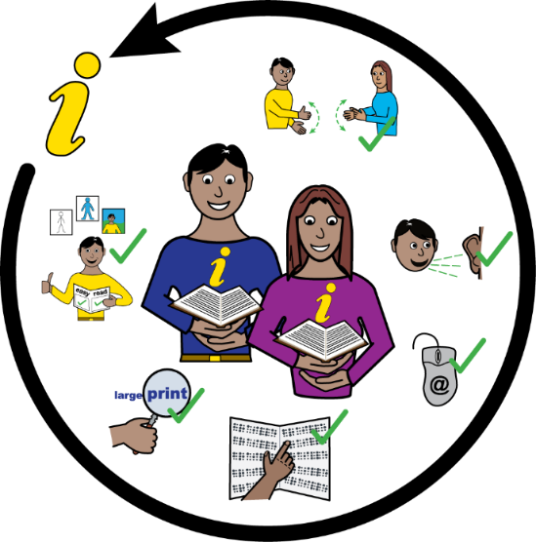 | - Adults can create child-friendly information
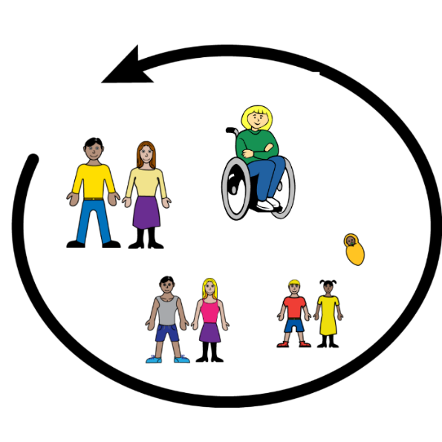 | - Adults can help children of all ages and backgrounds be included.
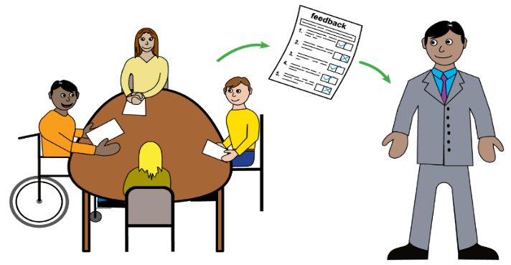 | - Adults can give children feedback on how their views have affected the decision.

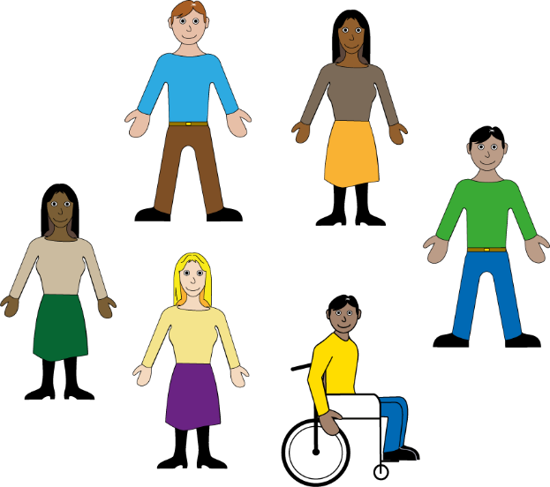 | Adults should include all children  It can be harder for some children to have their views heard because they are younger, disabled, speak another language or another reason.
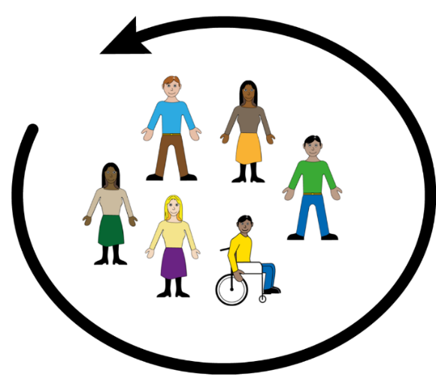 | It is important for all children to access information and opportunities to have their views heard.
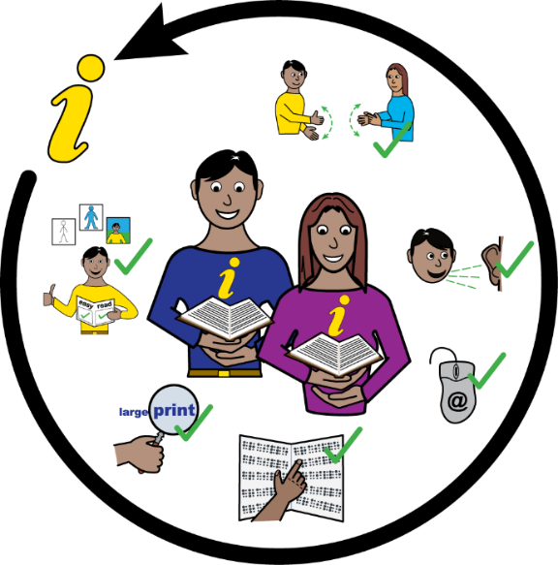 | Adults can help children by:  - using British Sign Language, Braille, interpreters or other things children might need to help them understand.
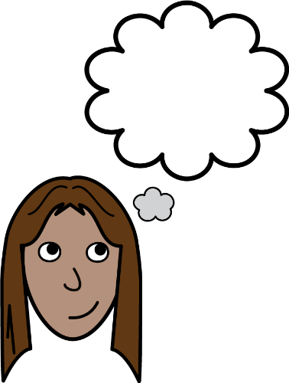 | - thinking about what children need when they are creating information and activities.
 | - making sure information is easy for children to find. This could mean using social media.
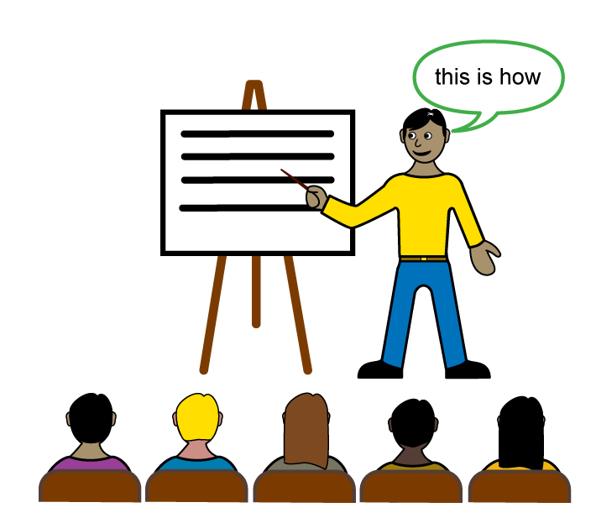 | - getting training on how to share ideas in ways that all children can understand.
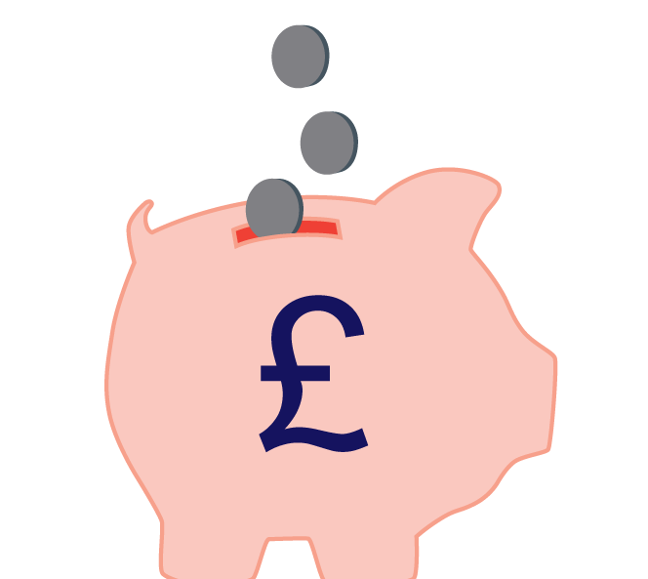 | - putting money aside for interpreters or other things children might need.

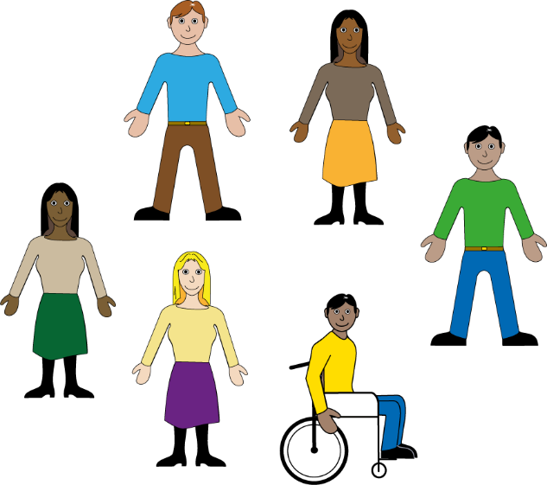 | Adults should look out for children who need extra help  Some children need extra help to make sure their rights are met.  This might be because they are disabled, live away from their family, or for lots of other reasons.  Here are some of the things adults should do:
 | Adults should collect information to find out who these children who need extra help are.
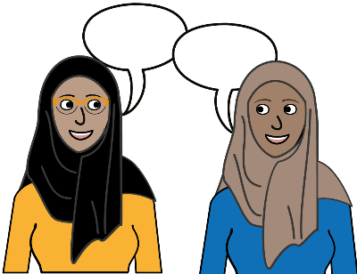 | Adults should gather children’s views as well as the important numbers.
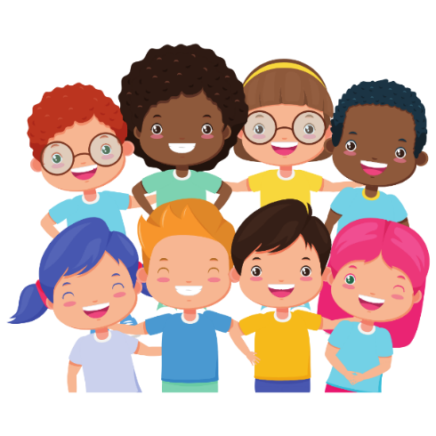 | - Adults should gather information about different groups of children so they can understand what different children need.
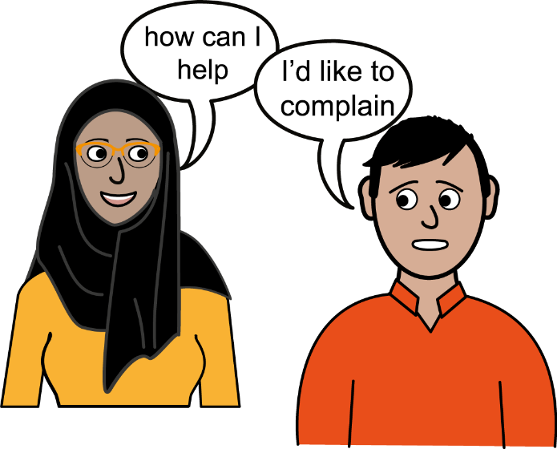 | Adults should make it easy for children to complain if things go wrong.  If children’s rights are not met, they should be able to make a complaint.  Adults can do lots of things to make it easier for children to make a complaint.
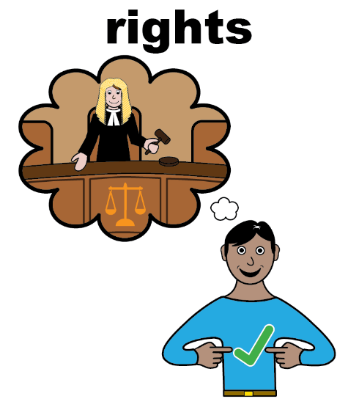 | Adults should help children know about their rights, so children know when something has gone wrong.
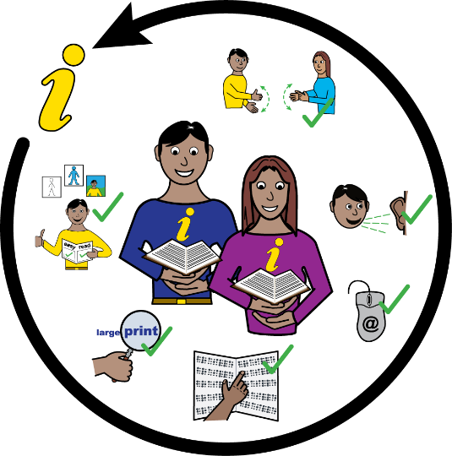 | Adults should make it easy for children to make a complaint by using British Sign Language, Braille, interpreters or other things that a child might need.
 | Adults should help children speak to a lawyer if they need one.

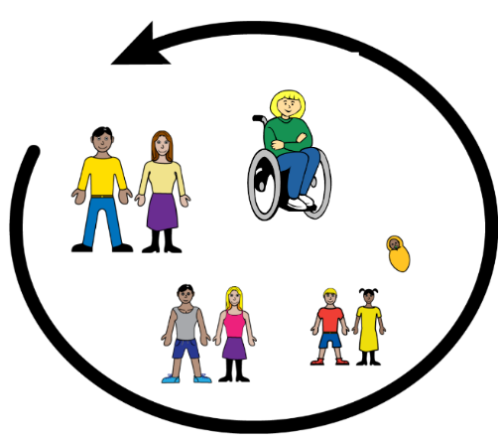 |  | Adults should learn about children’s rights.  Everyone should know about children’s rights - both children and adults.
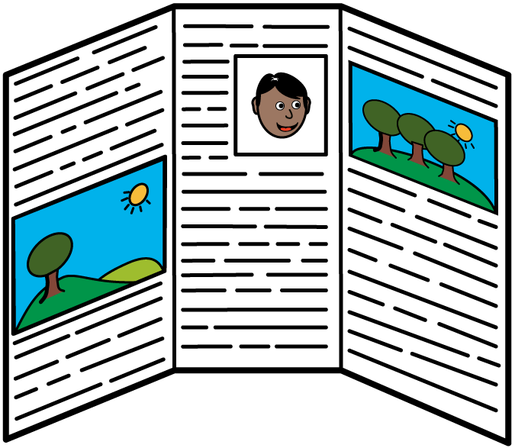 |  | There are lots of ways to make sure this happens - like learning about rights at school, posters, leaflets, shows, adverts and training for adults.
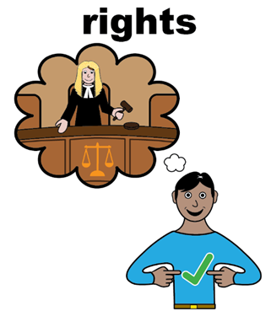 |  | If children know their rights, they will know when they are not being respected.  They can then complain so that things are put right.
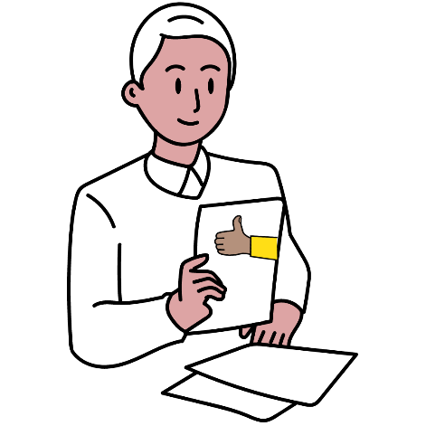 |  | If adults know about children’s rights then they will know how to make things better for children.
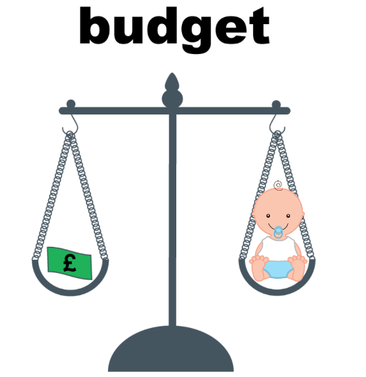 | Adults should think about children’s rights when they are making decisions about spending money.
 | If adults do not think about children’s rights when making decisions about money, then they might spend it on something that is not important for children.
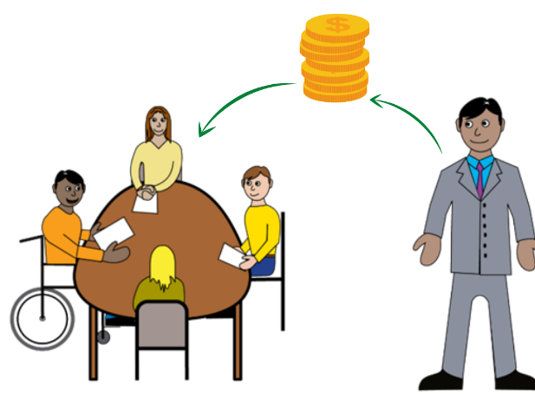 | Adults should involve children in decisions about spending money.
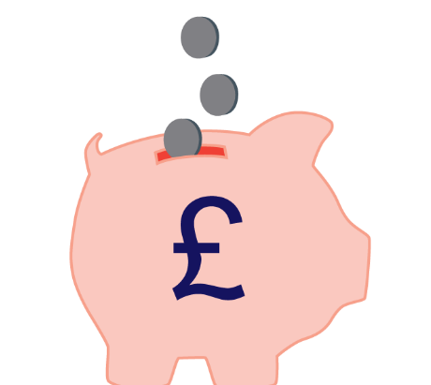 | Adults should use as much money as they can to protect children’s rights, before spending it on anything else.
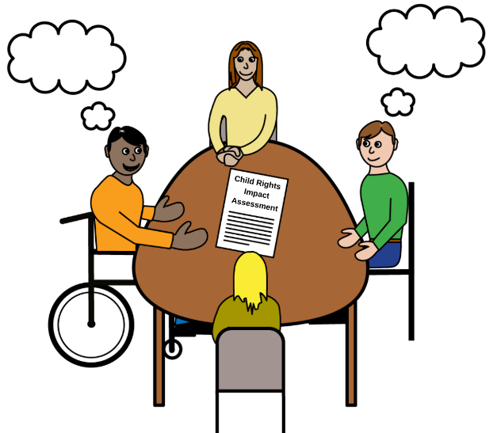 | Adults should think about children’s rights when making decisions.  A special tool can help adults do this. It is called a Child Rights Impact Assessment.
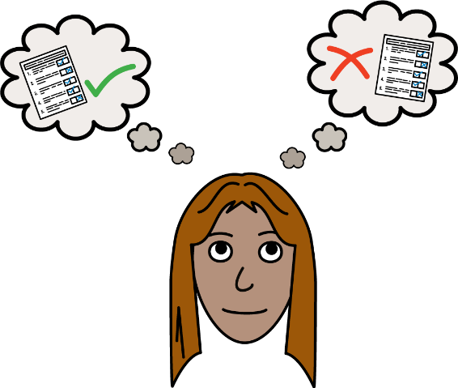 | A Child Rights Impact Assessments is a list of questions that adults must answer.  These questions help adults to think about their decisions and make changes to their ideas.
 | Adults should do Child Rights Impact Assessments early so there is time to make changes to their decision.
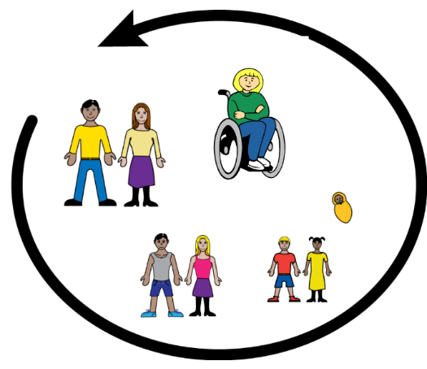 | Adults should involve children of all ages and backgrounds when answering questions.

