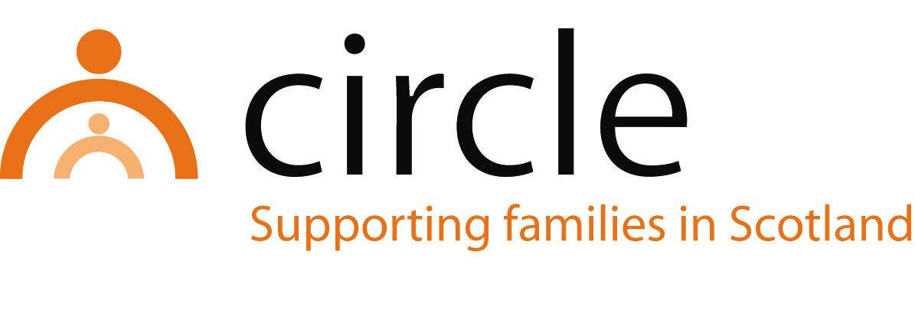

JOB DESCRIPTION
Family wellbeing practitioner
Harbour Project – Sparrow Service

Number of Hours: Part Time (28 hours per week)

Salary Scale: Pro-rata to £26,870- £31,144 per annum (SCP 12 - 17)

Accountability of post: The postholder will be line managed by and accountable to the Project Manager, Circle, for the performance of the tasks described below.

Main Purpose: To provide support for birth parents that have a child who is permanently fostered, adopted or in kinship care. The post holder will engage parents through intensive, one to one support.

Location of post: Circle Head Office, 18 West Pilton Park, Edinburgh, EH4 4EJ

MAIN TASKS & RESPONSIBILITIES:

- To support parents to make meaningful changes to improve their life circumstances
- To enable parents to develop their understanding of children’s needs and where possible, enhance relationships with their children
- To link birth parents with appropriate supports and reduce isolation and stigma
- To record, monitor and evaluate all work
- To attend supervision, team meetings and in-house training sessions as appropriate
- To contribute to the promotion and development of Circle’s work and services in Edinburgh
- To work closely with partner agencies to meet the needs of birth parents and their families
- To work within Circle’s policies and procedures, most notably in areas of child protection, equal opportunities, anti-discriminatory practice, and user participation
- To attend Staff Development Days

With consultation, amendments may be made to your job description from time to time in relation to our changing needs and your own ability.

PERSON SPECIFICATION
Family wellbeing practitioner
Harbour Project – Sparrow Service

QUALIFICATIONS
ESSENTIAL

- A professional qualification in social work, social care, education, or health

KNOWLEDGE & EXPERIENCE
ESSENTIAL

- Knowledge of a range of interventions for supporting parents
- Experience of providing support using a rights-based approach
- Experience of working in partnership with other agencies
- Experience of working as part of a team
- Knowledge of child development and issues affecting vulnerable children and families
- Knowledge of the GIRFEC approach and the related SHANARRI indicators
- An understanding of and commitment to equal opportunities, anti-discriminatory practice, and user participation

SKILLS & ABILITIES
ESSENTIAL

- Ability to communicate effectively with children and adults
- Ability to support social work students on placement with Circle
- Ability to record, monitor and evaluate work
- Ability to plan and prioritise work
- Ability to effect change in families
- Ability to work across professional boundaries
- Good assessment skills

