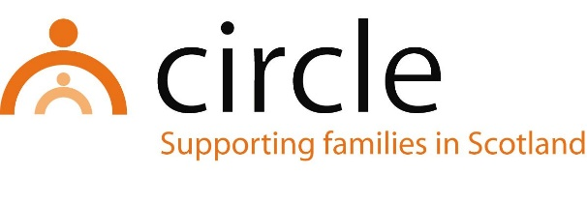

JOB DESCRIPTION
FUNDRAISING OFFICER

Number of Hours: | Full-time (36 hours per week)
Salary Scale: | £28,593 - £32,588 (SCP 14 - 19)
Accountability of post: | The post holder will be line managed by and accountable to the CEO of Circle for the performance of the tasks listed below
Main purpose: | - To maximise income with a focus on events, corporate and individual fundraising  - To raise the profile of Circle with a focus on internal and external communications and social media content
Location of post: | Head Office, Edinburgh (Hybrid working an option)

MAIN TASKS & RESPONSIBILITIES:
Event fundraising
- Play a key role in the development and implementation of Circle’s community fundraising activities and events to significantly increase our income.
- To lead on sustaining and developing events including our DARED running challenge, the Kiltwalk and other events where appropriate.
- Develop and plan bespoke annual fundraising event to raise awareness of Circle’s work and increase Circle’s income.
Individual fundraising
- Lead Circle’s work in engaging with different communities, including supporters, community groups and businesses, and encourage their support for Circle’s work to raise income (e.g., Youth Philanthropic Initiative activities).
- Implement Circle’s individual giving programme to include the recruitment, reactivation and retention of regular donors.
Corporate fundraising
- Research and development to conclusion of corporate partnerships (e.g., charity of the year).
- Research and development of corporate event sponsorship packages.
Communications
- To work closely with the Circle CEO, Management team and Fundraising team to raise awareness of the work Circle does, our approach and our values.
- To work closely with the Fundraising team to develop internal relationships with Circle staff and projects that enable formulation and dissemination of insightful, inspirational and motivational charity content and awareness of Circle’s work across all social media platforms such as Facebook, Instagram, LinkedIn and Twitter.
- To work closely with the Fundraising Team to manage the external communications and ensure we are delivering high quality and engaging content for the Circle website, quarterly newsletters and other external communications.
General duties
- To work closely with the Circle CEO, Management team and Fundraising team to deliver and review current communications, fundraising and organisational strategies.
- To attend one-to-ones, team meetings, management meetings and staff development days as required.
- Contribute to the development and upkeep of inhouse database records and maintain complete and accurate records relating to fundraising, marketing and communications activities, and report on their performance on a regular basis to the Management team as required.
- Any other fundraising duties as required.

With consultation, amendments may be made to your job description from time to time in relation to our changing needs and your own ability.

PERSON SPECIFICATION
EVENTS OFFICER

KNOWLEDGE & EXPERIENCE
Essential

- Experience of contributing to the management of successful community event activities including successful stewardship of event fundraisers and volunteers
- Experience of contributing to successful corporate fundraising relationships and initiatives
- Experience of contributing to successful funding proposals
- Experience of fundraising databases
- A good working knowledge of Microsoft Word, Excel, PowerPoint, Outlook and various social media platforms

SKILLS, ABILITIES & APTITUDES
Essential

- Excellent written, communications and organisational skills
- Ability to effectively promote the work of Circle within and outside the organisation
- Ability to manage a demanding workload and meet deadlines
- Ability to develop good working relationships with colleagues and external stakeholders
- Ability to manage and prioritise own workload

ATTITUDES
Essential

- Commitment to the values of Circle
- Commitment to anti-oppressive and discriminatory practice
- Commitment to continuing professional learning and development

