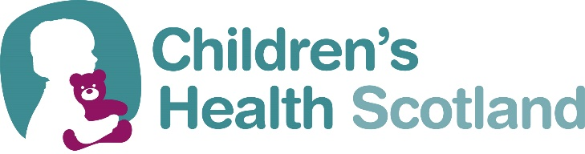

TRUSTEE RECRUITMENT
​Are you passionate about supporting the right of every child to the best possible health? Children’s Health Scotland is the leading children’s health charity in Scotland. We provide health and wellbeing support programmes directly to children and young people with health conditions and Foster and Kinship Carers. We’re the only charity in Scotland dedicated to informing, promoting, and campaigning on the healthcare needs and rights of all children and young people with health conditions and we work directly with children and young people, and those who love and care for them including families, carers, educators, and health professionals.
ROLE
We have been working hard on our new 2024-30 Children’s Health Scotland Strategic Plan and we are now seeking to recruit new trustees to join us on the next stage of our development. Our trustees play a vital role in making sure that we achieve our core purpose as outlined in our Constitution. They always act in the best interests of our charity and ensure that we have a clear strategy so that our work and goals are in line with our vision. Trustees have a collective responsibility which means they always act as a group and not as individuals.
JOIN US
This is an incredible opportunity to make a difference with health and wellbeing of children and young people in Scotland, particularly those living with long-term health conditions. We are currently recruiting for Trustees with experience in the following areas:
- Leadership roles in children and families and child-protection focused services (i.e. social work, education, healthcare, family support)
- Charitable / third sector – delivery and governance
- Policy, law and advocacy
- Marketing, Fundraising and income generation
No previous board experience is necessary as support will be provided. What we do need are trustees who are committed to our values and understand the current issues affecting the health and wellbeing of children and young people and their right to the best possible health. The most important attributes of trustees joining us include:
- A willingness to ask questions
- A shared belief in our values, aims and objectives
- Energy to be an active and engaged trustee
- A desire to be a champion for children and young people and our organisation.
Your responsibilities
Being a trustee requires a time commitment to the role. Duties/tasks include:
- Attending and contributing at our Executive Committee Meetings (mostly online).
- Taking part in development sessions with staff and/or trustees
If this sounds like an opportunity you can bring your time, skills and passion to – we would love to hear from you. Please contact our Chief Executive on 0131 553 6553 or email helen.forrest@childrenshealthscotland for more information.

