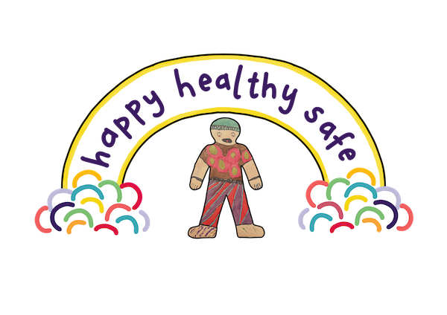

**Children’s rights learning journal**

**For the public authority workforce in Scotland**

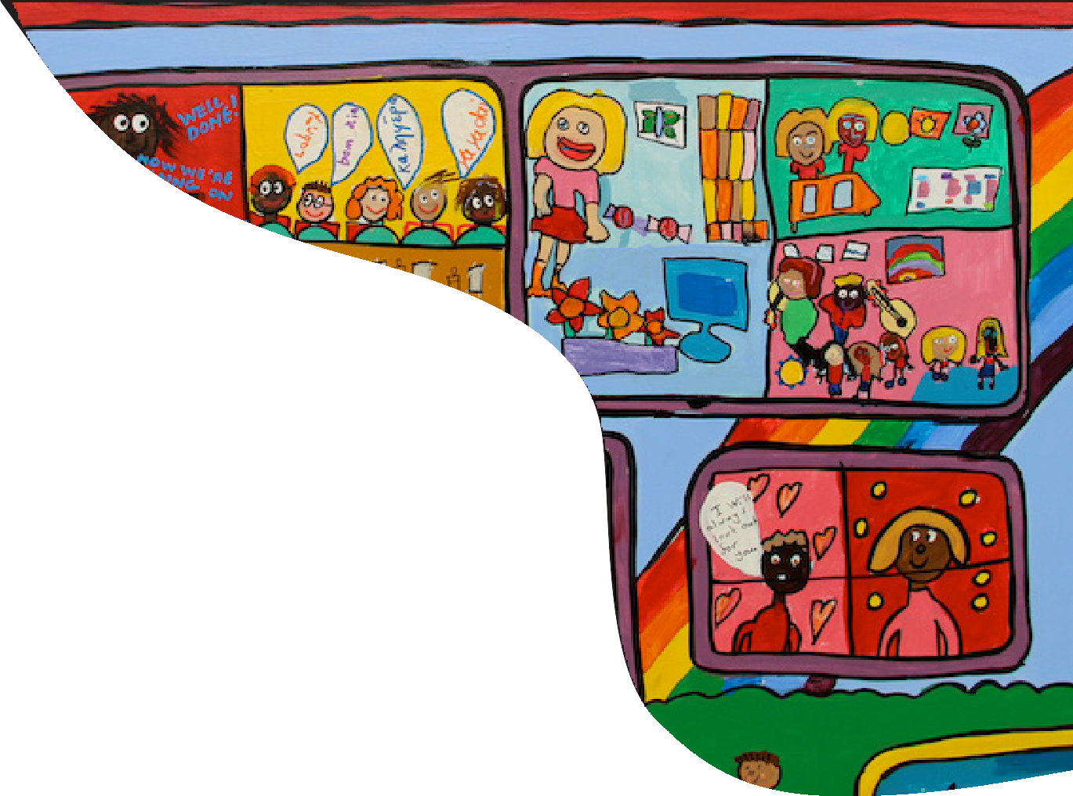

**Learning journal**

**This learning journal is designed to accompany the Children’s Rights Skills and Knowledge Framework.**

You can use it on your journey through the [Framework](https://www.togetherscotland.org.uk/framework/).

Learning about children’s rights is an ongoing reflective process and something you can return to as often as you like throughout your work.

Use this journal as part of your ongoing professional development planning. It will be useful for discussion with line managers, for reflection on practice with children and young people and to refresh your knowledge of children’s rights during appraisals.

The journal contains the following sections:

* Reflections on the learning outcomes.
* Next steps and action log.
* Further discussion and reflection questions.
* Notes on language.
* Notes on resources.
* Blank notes section.

Learning journal Page 2

Learning journal Page 3

Use this section to evidence how you already meet the learning outcomes in the Framework. This could include a personal reflection on your progress or feedback you have received.

Examples:

**“As a teacher I would make sure that I create a learning environment that is inclusive by differentiating resources and taking time to listen to my pupils’ concerns.”**

**“As a city planner I would make sure to use consultation techniques to effectively involve and encourage children and young people to take an interest in spatial issues such as the Local Development Plan, Play Sufficiency Assessment and Open Space Strategy. Not consulting them as future participants in public spaces, but as current participants who use the space in their own way.”**

**“As an officer in the prison service, I can make sure children and young people affected by a loved one who is incarcerated feel valued and engaged with, considering how to make visiting hours and spaces suitable for them.”**

You can also use this section to record learning outcomes and specific skills or knowledge statements where you would like to continue improving your understanding or practice. You might like to include how confident you feel with the objective on a scale of 1-10.

**1. Reflections on the learning outcomes**

**1. Reflections on the learning outcomes**

Learning journal Page 4

|  |  |  |  |
| --- | --- | --- | --- |
| **Principle** | **Outcome and  resource list** | **Evidence that you already  meet the outcomes** | **Reflections about outcome(s)  where you want to continue learning** |
| **A puzzle with different symbols  Description automatically generated with medium confidenceEmbedding**  **A puzzle with different symbols  Description automatically generated with medium confidenceEmbedding**  **A puzzle with different symbols  Description automatically generated with medium confidenceEmbedding** | I want to understand how to embed a children’s human rights approach in my work.  [Resources](https://www.togetherscotland.org.uk/framework/learning-library/embedding/embedding/)  I want to ensure that children's rights are embedded in planning, strategies, and reporting.  [Resources](https://www.togetherscotland.org.uk/framework/learning-library/embedding/planning/)    I want to ensure that children's rights are built into everything we do and understand the links to other policies and frameworks. [Resources](https://www.togetherscotland.org.uk/framework/learning-library/embedding/policies/)  I want to ensure that children's rights are taken into account when commissioning services and developing partnerships with wider organisations and services. [Resources](https://www.togetherscotland.org.uk/framework/learning-library/embedding/commissioning/)  I want to undertake Child Rights Impact Assessments and Child Rights Impact Evaluations to assess the impact of decisions on children and young people. [Resources](https://www.togetherscotland.org.uk/framework/learning-library/embedding/child-rights-impact-assessments/)  I want to understand how regularly collecting and monitoring appropriate information on children and young people can help to support their rights, particularly for children and young people whose rights are at risk. [Resources](https://www.togetherscotland.org.uk/framework/learning-library/embedding/monitoring/)  I want to understand how child rights budgeting can support children's rights, particularly for children and young people whose rights are at risk. [Resources](https://www.togetherscotland.org.uk/framework/learning-library/embedding/budgeting/)  Learning journal Page 5  I want to be aware of the most appropriate learning and training so I can develop my skills and knowledge to take a children’s human rights approach. [Resources](https://www.togetherscotland.org.uk/framework/learning-library/embedding/training/)  I want to know how to build relationships with services working with children and young people who might be able to provide support, contacts, and expertise for my work.  [Resources](https://www.togetherscotland.org.uk/framework/learning-library/embedding/relationships/)  I want to understand the role and functions of the Children and Young People's Commissioner Scotland and Scottish Human Rights Commission.  [Resources](https://www.togetherscotland.org.uk/framework/learning-library/embedding/cypcs-and-shrc/)  I want to understand how best to promote the rights of children and young people. [Resources](https://www.togetherscotland.org.uk/framework/learning-library/embedding/promote/) |  |  |

Learning journal Page 6

|  |  |  |  |
| --- | --- | --- | --- |
| **Principle** | **Outcome and  resource list** | **Evidence that you already  meet the outcomes** | **Reflections about outcome(s)  where you want to continue learning** |
| **A group of children standing on colorful boxes  Description automatically generatedEquality  and non-discrimination** | I want to learn how to support children and young people to have equal access to their rights, with a focus on those children and young people whose rights are at risk.  [Resources](https://www.togetherscotland.org.uk/framework/learning-library/equality-and-non-discrimination/access/)  I want to recognise and challenge potential concerns about children’s rights, especially those of children and young people whose rights are at risk.  [Resources](https://www.togetherscotland.org.uk/framework/learning-library/equality-and-non-discrimination/concerns/)  I want to understand children and young people’s lived experiences, including those whose rights are at risk.  [Resources](https://www.togetherscotland.org.uk/framework/learning-library/equality-and-non-discrimination/experience/) |  |  |

Learning journal Page 7

|  |  |  |  |
| --- | --- | --- | --- |
| **Principle** | **Outcome and  resource list** | **Evidence that you already  meet the outcomes** | **Reflections about outcome(s)  where you want to continue learning** |
| **A hand holding a cartoon character  Description automatically generatedEmpowerment**  **A hand holding a cartoon character  Description automatically generatedEmpowerment** | I want to understand children and young people’s evolving capacity.  [Resources](https://www.togetherscotland.org.uk/framework/learning-library/empowerment/evolving-capacity/)  I want to support children and young people of all ages and backgrounds to express their views and have the chance to talk about what is important to them.  [Resources](https://www.togetherscotland.org.uk/framework/learning-library/empowerment/views/)  I want to take children and young people's views into account in decisions that affect them.  [Resources](https://www.togetherscotland.org.uk/framework/learning-library/empowerment/decisions/)  I want to give children and young people information about things that affect them in a way they find easy to understand.  [Resources](https://www.togetherscotland.org.uk/framework/learning-library/empowerment/information/)  Learning journal Page 8  I want to support children and young people as human rights defenders, to stand up for their own rights and for the rights of other children and young people.  [Resources](https://www.togetherscotland.org.uk/framework/learning-library/empowerment/defenders/)  I want to ensure that children and young people are given spaces (in-person and online) where they can freely associate and advocate for their rights. [Resources](https://www.togetherscotland.org.uk/framework/learning-library/empowerment/associate/)  I want to build empowering relationships with children and young people.  [Resources](https://www.togetherscotland.org.uk/framework/learning-library/empowerment/empowering/)  I want to be sufficiently trauma-informed to ensure my work supports children and young people who have experienced or are experiencing trauma.  [Resources](https://www.togetherscotland.org.uk/framework/learning-library/empowerment/trauma/) |  |  |

Learning journal Page 9

|  |  |  |  |
| --- | --- | --- | --- |
| **Principle** | **Outcome and  resource list** | **Evidence that you already  meet the outcomes** | **Reflections about outcome(s)  where you want to continue learning** |
| **A person pointing at a group of people  Description automatically generatedParticipation**  **A person pointing at a group of people  Description automatically generatedParticipation** | I want to ensure that children and young people are protected from harm and not put at risk through their participation. [Resources](https://www.togetherscotland.org.uk/framework/learning-library/participation/risk/)  I want to ensure children and young people are given full, accessible, age appropriate information about their right to express a view, and how it will be taken into account.  [Resources](https://www.togetherscotland.org.uk/framework/learning-library/participation/information/)  I want to ensure that children and young people’s participation is voluntary. [Resources](https://www.togetherscotland.org.uk/framework/learning-library/participation/voluntary/)  I want to ensure that children, and young people can use various methods to express their views. [Resources](https://www.togetherscotland.org.uk/framework/learning-library/participation/methods/)  Learning journal Page 10  I want to ensure that participation is child friendly, with enough time, space, and resources to ensure children and young people feel confident to take part, whatever their support needs. [Resources](https://www.togetherscotland.org.uk/framework/learning-library/participation/child-friendly/)  I want to support workers with their skills development to take a children's rights approach to participation.  [Resources](https://www.togetherscotland.org.uk/framework/learning-library/participation/skills/)  I want to ensure that children and young people whose rights are at risk can play a full and meaningful part in decisions that affect them through inclusive participation.  [Resources](https://www.togetherscotland.org.uk/framework/learning-library/participation/inclusive/)  I want to ensure that children and young people are given feedback on the outcomes of their participation and give feedback as part of the participation process.  [Resources](https://www.togetherscotland.org.uk/framework/learning-library/participation/feedback/)  Learning journal Page 11 |  |  |

|  |  |  |  |
| --- | --- | --- | --- |
| **Principle** | **Outcome and  resource list** | **Evidence that you already  meet the outcomes** | **Reflections about outcome(s)  where you want to continue learning** |
| **A drawing of a checklist and a speech bubble  Description automatically generatedAccountability** | I want to ensure that accountability is built into my children’s human rights approach.  [Resources](https://www.togetherscotland.org.uk/framework/learning-library/accountability/approach/)  I want to ensure that actions and decisions are effectively communicated as part of accountable practice. [Resources](https://www.togetherscotland.org.uk/framework/learning-library/accountability/communication/)  I want to ensure that children and young people can provide feedback and have access to independent complaints procedures if they have concerns about their rights.  [Resources](https://www.togetherscotland.org.uk/framework/learning-library/accountability/feedback/)  I want to ensure that children and young people have access to advice and advocacy. [Resources](https://www.togetherscotland.org.uk/framework/learning-library/accountability/advocacy/) |  |  |

Learning journal Page 12

**2. Your next steps and action log**

Use this section to record any actions you would like to take after working through the Children’s Rights Skills and Knowledge Framework. Ensure every action has a milestone, goal or target so you will know if it has been completed and try to attach a deadline for accountability.

|  |  |  |  |
| --- | --- | --- | --- |
| **Level** | **Action or aim** | **Milestone, goals or targets** | **Deadline** |
| Individual |  |  |  |
| Team |  |  |  |
| Organisational |  |  |  |
| Wider environment |  |  |  |

Learning journal Page 13

**3. Further discussion and reflection questions**

Use this section to summarise your ideas to help you take forward your knowledge of children’s rights

|  |  |
| --- | --- |
| **Question** | **Your ideas** |
| How are you going to take this forward? |  |
| What are the opportunities to take this forward? |  |
| Are there any barriers to taking this forward? How could you mitigate these barriers? |  |
| How are you going to embed this in your team? |  |
| How can you share what you have learned? Who do you want to share what you have learned with? |  |

Learning journal Page 14

**4. Notes on language**

Use this section to note down any words or phrases you want to better understand.

You can use the [online glossary](https://www.togetherscotland.org.uk/framework/glossary/) of words and phrases contained in the Framework to help you.

|  |  |
| --- | --- |
| **Word or phrase** | **Explanation** |
|  |  |
|  |  |
|  |  |
|  |  |
|  |  |
|  |  |
|  |  |
|  |  |

Learning journal Page 15

**5. Notes on resources**

Use this section to analyse what you have learned exploring children’s rights resources.

You can explore the linked resources throughout the learning outcomes or search the [Learning Library](https://www.togetherscotland.org.uk/framework/learning-library/) for specific topics.

|  |  |  |
| --- | --- | --- |
| **Resource name** | **What you learned** | **How it is relevant to your work** |
|  |  |  |
|  |  |  |
|  |  |  |
|  |  |  |
|  |  |  |
|  |  |  |
|  |  |  |
|  |  |  |

Learning journal Page 16

**6. Blank notes section**

Type your notes here…

Learning journal Page 17