
Our Hearings Our Voice: Creating a scrapbook to empower children and young people during children’s hearings
Established in 2015, Our Hearings Our Voice (OHOV) is an independent board for young people across Scotland who have lived experience of the Children’s Hearings System. Our aim is to ensure children and young people have a decision-making role in the improvement and reform of the Children’s Hearings System.

The issue or opportunity
Children require support before, during and after their hearings to understand how they can participate fully, comfortably, and safely. OHOV board members frequently stated that they felt underprepared for their children’s hearings and that their voices were often not heard.
Commonly cited issues included:
- Feeling unsure of their rights.
- Having to sit next to, or close to, somebody they didn’t feel comfortable with.
- Adults making decisions about young people’s lives without asking for their input.
- Difficulty understanding the decisions that were implemented within a hearing, and what this would look like in their lives.
- Adults being unaware of children and young people’s needs and preferences. For example, an aversion to bright lighting or difficulty making eye contact.
- Communication barriers preventing children from giving their input. This could be due to neurodivergence, differing communication styles, or reticence to speak out in an adult dominated setting.
These are just some of the barriers that prevent children and young people from fully participating in the children’s hearing, in accordance with their rights.

What was done
In response to these issues, children’s hearings experienced board members Ciara and Achilles developed a prototype for a ‘scrapbook’; an open-ended resource that empowers children and young people to take control over the design and facilitation of their children’s hearing.
It includes pages for children to express how they are feeling, to customise their hearing beforehand, and to record hearing decisions. It also contains information about their rights in the Children’s Hearings System and signposts where to get help and more information, written in a way that children can understand.
Ciara and Achilles envisaged the scrapbook being used by children and young people independently, or with a “trusted professional that the young person feels comfortable talking to… someone to sit down and go through the booklet with them.”

“My hope for the future is that it’s something young people feel connected to and it really helps them feel comfortable and safe in hearings.” Achilles, Board Member
Children and young people have reported that they often do not feel comfortable and safe in their hearings. Work is being done around Scotland to make hearings more trauma informed, and the scrapbook is one means by which children and young people can have a say in what ‘trauma informed’ means to them. Examples of this could include asking to sit separately from a certain person or letting adults know that they have a fear of lifts and should not be expected to use one to get to their hearing room.
Ciara and Achilles worked with communications staff from the Scottish Children’s Reporter Administration, along with a speech and language specialist who was able to advise on child friendly fonts and wording. The scrapbook was designed with simplistic, uncluttered information and visual aids presented in a neutral colour palette. Ciara and Achilles wanted children and young people to feel ownership of their scrapbook, so they designed it as an A5 ring binder, which allows pages to be added or removed. This design element affords “control from the young person about what they share.”

“It was a fun and interesting process, and I feel so proud to have co-created it!” Ciara, Board Member
The scrapbook was initially launched in November 2023 on a trial basis. It was sent to all children over the age of six who were attending their first hearing.
OHOV received some encouraging feedback; a child was excused from attending their Grounds Hearing following a Pre-Hearing Panel. The child’s father brought in the scrapbook to the hearing, and it was almost completely filled in. He advised that she wanted the panel to read the ‘My decisions’ page and a blank page on which she had written more of her thoughts. The panel members reported that this aided them in their decision making, and they were pleased to have information that had come directly from her. In addition, the father said the child loved the scrapbook and intended to use it for future hearings, just as Ciara and Achilles had envisioned.
Following a successful trial in Fife, and four other areas in Scotland, both scrapbooks have now been rolled out across Scotland. All children and young people will now be sent a scrapbook in advance of their hearing.

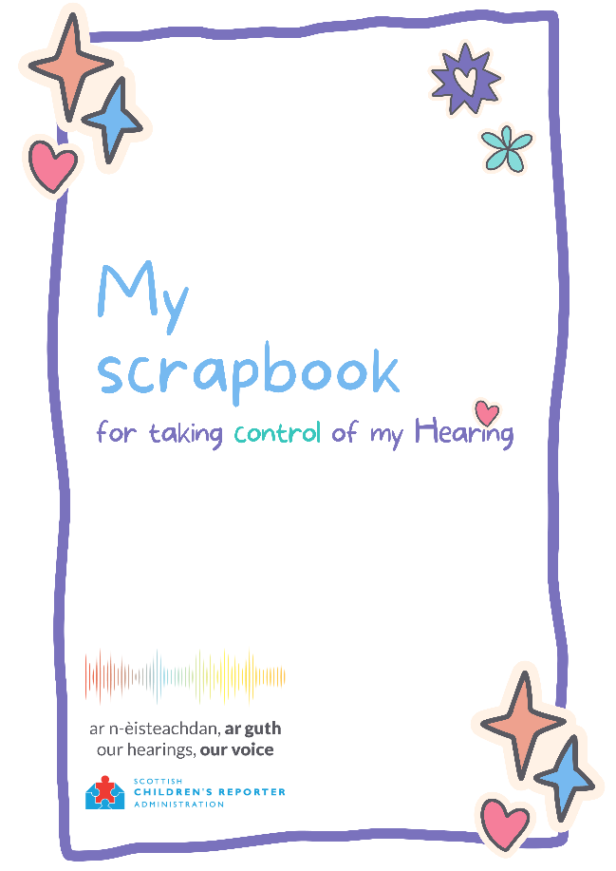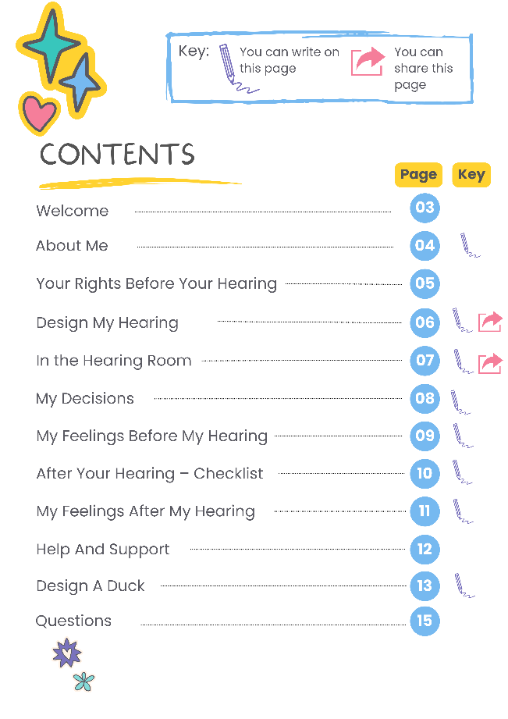
The front cover and contents of the Scrapbook
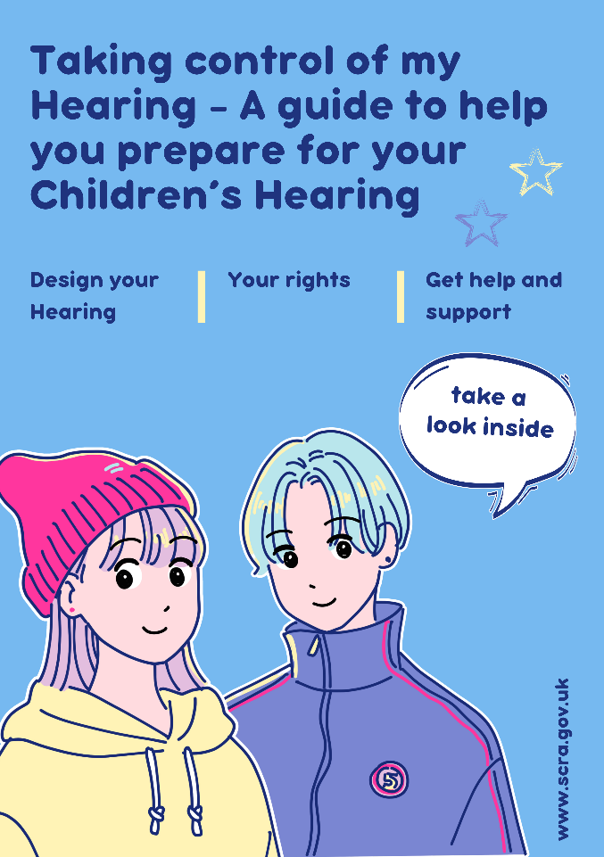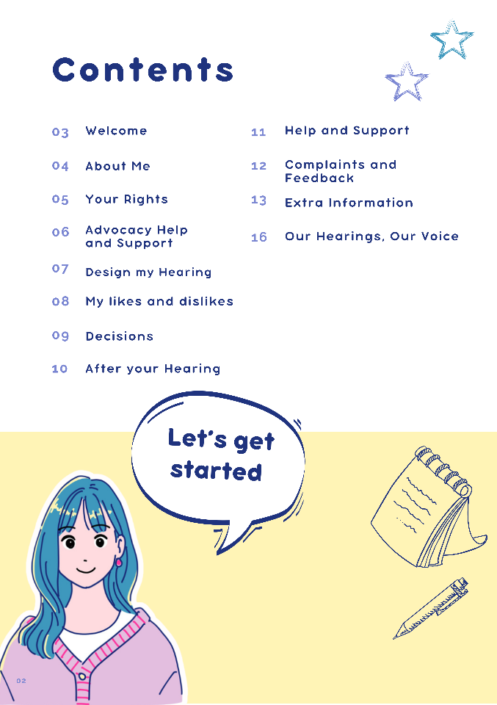
The front cover and contents page of the alternative scrapbook

Children’s human rights approach principles in practice
This work, driven and designed by young people with care and hearings experience, supports the agency and capacity of children and young people to claim their right to be heard. The different levels of resources support children and young people’s evolving capacity. These initiatives empower children, including younger children, disabled children, and children in care, to express their views and to have them considered in all decisions affecting them, including in courts and relevant judicial proceedings and placement in alternative care.

