
Inverclyde Council: Connected 2 Care Conference 2024
Inverclyde Council believes that compassion and kindness are at the heart of our communities and partnerships across the authority, however our wonderful children and young people are at the heart of everything we do. Putting children and young people at the heart of everything the Council does means listening, engaging, and finding new creative ways to deliver services. Our young people are a source of inspiration and a positive force for good across the Council and communities.

The issue or opportunity
An opportunity arose for some of our care experienced children and young people to get involved in a leadership academy with Columba 1400’s place-based project. This was instigated by our education services through our virtual school head teacher and was implemented in partnership with our Children’s Rights Officer and Your Voice Inverclyde who are a third sector organisation that we work closely with.

What was done
Each high school in Inverclyde was asked to nominate three young people to get involved. Through working with the academy, the young people decided that a conference was the best way to share their thoughts. Therefore, they were supported to design and deliver a full day conference exploring what care experience meant to them and how our workforce and communities can better support children, young people and their families to thrive.
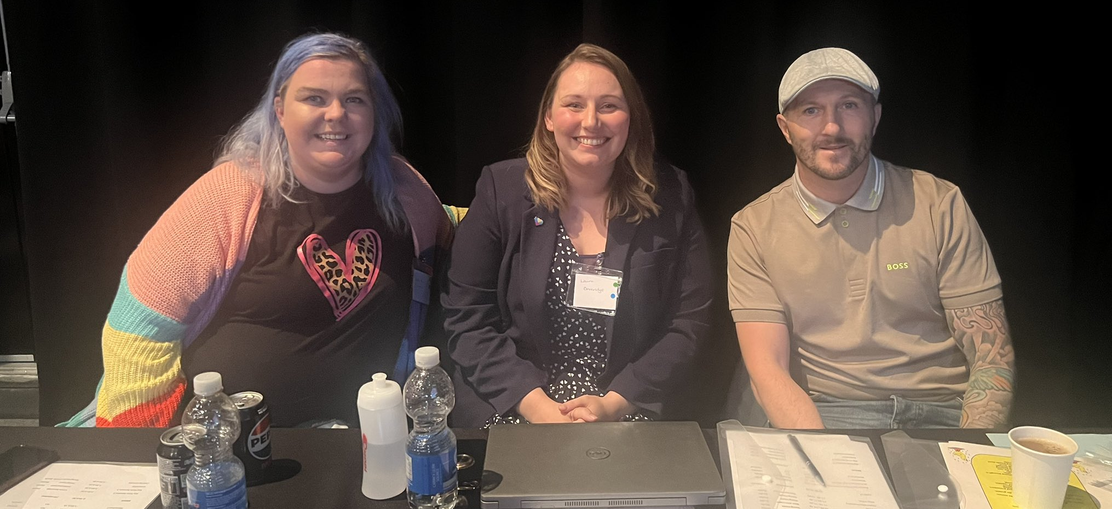
Conference speakers Beth Anne McDowall, Laura Beveridge and James Docherty.

As part of the discussions the young people decided that each school should plan and facilitate their own workshop or presentation on the day. These included workshops on:
- Mental health and its impact.
- Social work and the care system, building better relationships and connections.
- Stigma around being care experienced.
- Bullying and its impact.
- The power of connections and how one nurturing adult can help us create more positive pathways.
The young people also invited some keynote speakers who they had researched and felt were the people who were aligned with their ideas and what they wanted to achieve from this conference. The Keynote speakers were Beth-Anne McDowall, Laura Beveridge and James Docherty. One of our schools was supported by Ian Corbett from the Children and Young People’s Centre for Justice.
The aim was for the conference to be fully youth led, from design to delivery, and to give Inverclyde’s workforce and wider community an opportunity to listen and then respond through their own practice with an enhanced understanding of our care experienced communities’ needs and aspirations (#ListenAndRespond). The young people achieved that aim and so much more. 128 corporate parents from across the whole local authority turned up for the event and the feedback was outstanding. This included representatives from education, health, social work, advocacy, housing, fire, police and so many more people who play a massive part in the lives of young people whose rights are at risk.
As this was youth led from start to finish, their involvement included budgeting, planning, hosting, backstage support and all aspects of the event. Equality and non-discrimination, inclusion, and participation were crucial elements of the event, which showed throughout as no decisions were ever undertaken without the young people. However, the main reason for the success was choice. At no point was any young person asked to do anything that they didn’t feel equipped to. We did encourage young people to step outside of their comfort zones but always in a safe space and never to their detriment at any point. This gave the young people the confidence to try new things at their own pace. The level of empowerment this gave the young people was not something we could have imagined at the start of this project but absolutely shone throughout this whole event.
We worked to support the young people to be confident enough to be able to facilitate a group or present on the day. This was making them feel a bit worried so we discussed what they felt would be achievable for them to manage. Every single young person within this cohort was at a different stage, so we made sure that they all felt fully
included. Through some problem solving and them overseeing decisions, the young people who didn’t want to present or facilitate groups came up with a great idea for an anti-bullying and kindness stall they could host on the day. The young people worked on what resources they would need for the stall, and how they would like it to run throughout the day of the conference. They looked at what costs would be for the resources and how they would order these.
The young people taking ownership of this meant that they felt fully included and equal with everyone else who had a role within the conference. It also helped increase their confidence in knowing they didn’t have to step too far out of their comfort zones but far enough to be pushing themselves a bit. This example shows how we promoted inclusion, participation, equality and non-discrimination throughout to the benefit of the young people we were supporting.
We also had one pilot primary school get involved. Whilst they weren’t involved in the overall planning due to age, stage and choice, they did however make their own video which was shared on the day about the importance of nurture, support and interventions at an early stage.
As this was the first time we had been involved in such a project, there were, as expected, a few barriers to be overcome. One of the first ones we encountered was how to ensure accurate communication with schools, regarding what the project entailed. When our initial cohort of young people first arrived, they were unsure what they were coming along to. This meant that we could potentially be exposing young people’s stories unintentionally without their knowledge or consent. We worked closely with the young people and the schools to overcome this and although initially a barrier, it made for an interesting discussion point around stigma and privacy.
One key learning point from this conference was believing in the power of young people. With support and encouragement, they were able to not only reach their potential but smash through their own perceived limitations.
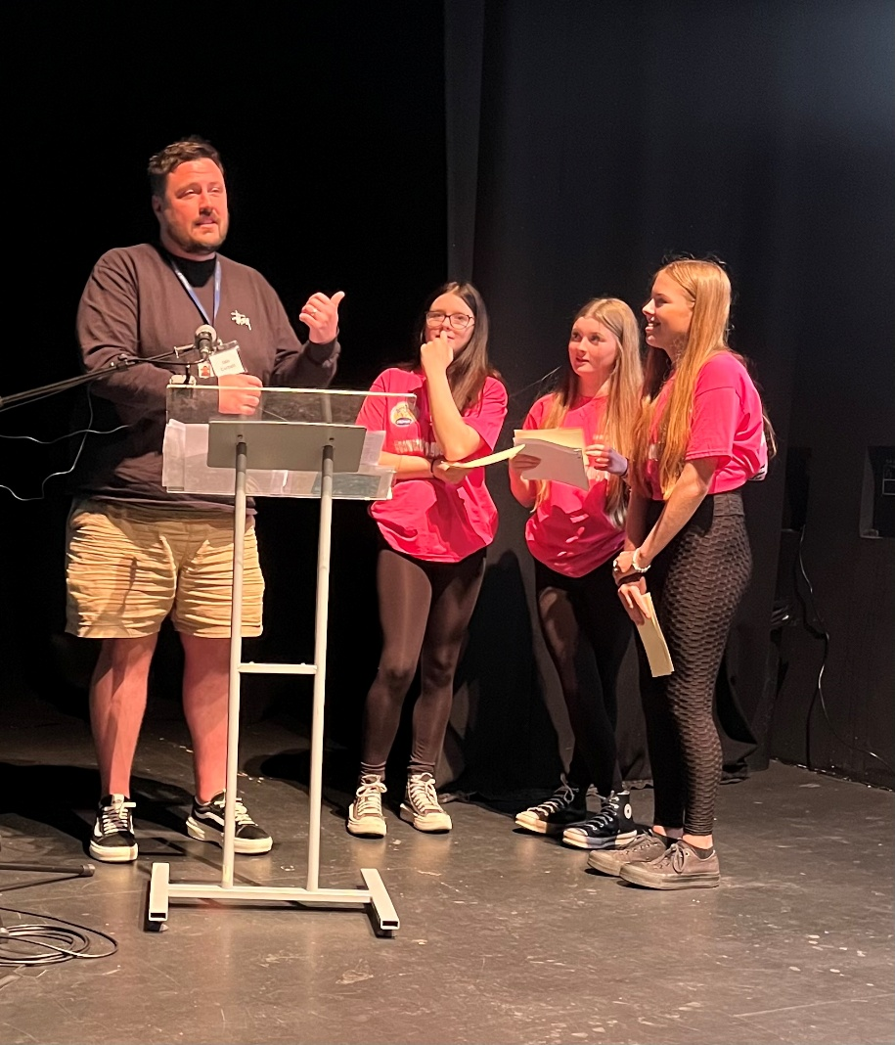
A session from the Connected 2 Care conference

“Throughout all of this time and being involved in championing change in Inverclyde, what we have really come to realise is that we have built the foundations of longlasting, trusting and supportive relationships. Through this conference, the connections we have made - not just with each other but with our corporate parents and other adults in our lives - have made such a difference to ensure we know we are not just heard, but responded to. These relationships are helping us to create more positive pathways for ourselves and ensure that other young people have these same opportunities.” Young people involved in the project

Children’s human rights approach principles in practice
Our work supports care experienced young people to have equal access to their rights, allowing them to share their experiences and their concerns about their rights so professionals can learn about their lived experience. This approach implements equality and non-discrimination by deeply exploring the needs of the care experienced children and young people. It facilitated the empowerment and participation principles by creating space for children to conceptualise, design and deliver the conference.

