
Shetland Council: Youth Voice – refreshing youth participation in Shetland

The issue or opportunity
With a declining youth and working age population it is vital to understand young people’s needs more effectively in Shetland, ensure Shetland Council is supporting young people to be heard, and that local public bodies actively engage with young people in the work they do.

What was done
Shetland Youth Voice is dedicated to empowering young people across the Shetland Islands. The ongoing programme aims to engage young people in meaningful participation within their communities, fostering leadership, advocacy, and positive change. By creating a platform where young individuals can express their ideas, opinions, and concerns, the project ensures that their voices are heard and valued in all aspects of community life. The work is promoted and facilitated by Shetland Islands Council’s Youth and Employability Service, who support the recruitment and organise the logistics of the meetings and activities of the group.
Shetland Youth Voice is a voluntary group comprising of young people between 12 and 26 working in different roles:
- General Members who have a commitment to meet four times a year.
- Executive Members who meet more regularly and take the actions discussed from the general meetings.
- Leadership are office-bearing roles within the Executive such as Chair, Secretary, Communications.
All secondary schools and voluntary organisations across Shetland are represented with members meeting quarterly to discuss key issues and participate in themed activities. This inclusive structure ensures that a diverse range of young voices are heard and that leadership opportunities are available at multiple levels, fostering a culture of empowerment and engagement within the youth community.
Shetland Youth Voice provides a mechanism for participation and voice for young people in Shetland. It also supports services and organisations to be able to engage and listen to their views, take them seriously and be accountable for the engagement, providing a feedback loop and updates on how the work has shaped future plans, polices and actions in the community.
Shetland Youth Voice activities range from workshops and events involving over 100 young people (based around their chosen annual themes), to wider surveying of the youth and school age population needs in Shetland, to promotional activities and campaigning. The issues and themes they will work on are decided each year by young people. Examples from last year include Transport, Mental Health, Fair Work and Youth Spaces.
For a young person in Shetland, engagement can differ depending on commitment and interest. Quarterly summits involve more members, but Executive members hold more regular meetings. The summits involve focusing on one of their chosen issues so that young people can opt in or out depending on their passions and interests in the subject.
Partnership with other services and community organisations is vital so at each summit there will be input from various organisations depending on the theme. They are then asked to feedback to the Youth Voice members on what action they have taken at the end of the year.
Transport was voted as the Shetland Youth Voice’s number one priority in October 2024. Members identified it as essential to education, employment, and social life, as well as influencing whether young people stay in Shetland long-term. The Summit aimed to explore the challenges and co-design solutions with transport leaders, from local councillors to the Chief Executive of Transport Scotland.
The event featured four themed workshops:
- Transport Connectivity in Shetland with Council Transport Officers – mapping journeys, identifying gaps in timetables, and discussing integration of bus and ferry services.
- Public Transport Issues in Shetland with SIC Elected Member – exploring accessibility, affordability, reliability, and safety.
- School Bus Transport with Shetland Islands Council’s Executive Manager and Schools – sharing positives and tackling negatives such as overcrowding, behaviour, and vehicle condition.
- Air Travel with Loganair airline – discussing costs, reliability, and proposals for better youth discounts.

Impact and outcomes
Three headline recommendations emerged:
- Extend bus schedules (especially Sundays).
- Improve young person discounts for off-island travel.
- Enhance safety on late night buses.
Shetland Youth Voice members presented their findings to SIC’s Environment and Transport Committee, as well as to the Scottish Government Minister for Transport and Connectivity. This secured praise from councillors and a commitment to explore potential changes.
Feedback from members at the summit showed high enjoyment (average rating 8.1 out of 10) and strong perceived learning (average rating 7.9 out of 10), with participants reporting greater confidence to speak up (average rating 8.0 out of 10).

“Young people in Shetland face real challenges with transport. Limited services, high costs, and safety concerns all make it harder for us to get to school, work, and social activities. The Transport Summit gave us the chance to share our views, and we hope to see real action taken.” Shetland Youth Voice member
Following this event, Shetland Islands Council amended their bus timetables to include an extra bus leaving Lerwick in the evening and are looking at introducing extra lighting in bus stops. Transport Scotland have stated this event influenced their decision to incorporate inter-island ferries in their Free Bus Travel for Under 22s.
These updates were provided directly to young people at Shetland Youth Voice’s ‘Year in Action’ event in November 2025 so they can hear what impact they made and what actions organisations have taken by listening to their views and needs.
Other examples of organisations being more accountable to Shetland Youth Voice are:
- Children Services signing a Pledge on Positive Relationships in Schools.
- Leading Inservice training for all Children Services Staff in October 2025.
- Pilot on social and recreational space for young people in Shetland to be introduced in January 2026.
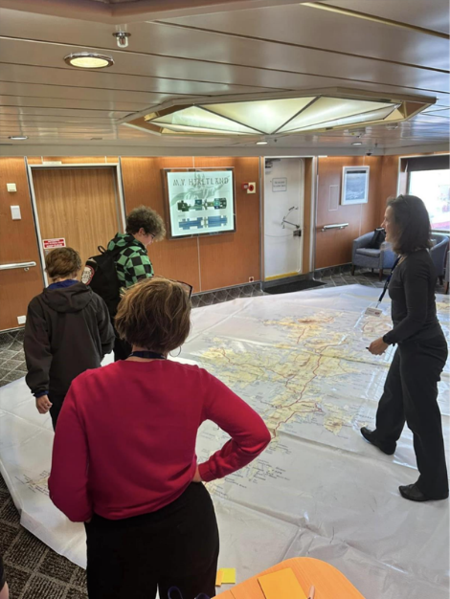
Young people sharing their views during a workshop

Next steps
Priorities for next year have included Education and Learning, Culture, Creativity and Arts, Environment and Nature. The Youth Voice members have also been provided with funding from Shetland’s Community Local Led Development fund to distribute to youth groups small grants of up to £1,000 if they meet their current priorities in Shetland’s community.

Children’s human rights approach principles in practice
The work of Shetland Youth Voice demonstrates the power of participation in action. While ensuring participation is voluntary and child friendly, children and young people are given the chance to influence their communities, and the participation process gives feedback on the results of their inputs.

