
Families Outside: Embedding children’s right to maintain contact with an imprisoned parent
Families Outside is Scotland’s only national charity dedicated solely to supporting children and families affected by imprisonment. The organisation is funded by the Scottish Government to provide project management, including the monitoring of performance and dissemination of good practice, to Prison Visitors’ Centres in Scotland.
A core function of every Visitors’ Centre is to promote the rights of children under the UNCRC, like Article 9: the right of the child to maintain personal relations and direct contact with both parents, except where this is contrary to the child’s best interests.
This case study highlights how one Prison Visitors’ Centre team sought to highlight this right with the prison they work alongside.

The issue or opportunity
Staff within a Prison Visitors’ Centre were made aware that a father, who attended children’s visits and their ‘Dads’ Group’, had his visits cancelled as a sanction when he tested positive for using illicit substances. While safety and security are paramount within a prison, this cancellation appeared to be applied without consideration of the impact on the child or the child’s rights.
In this case, the father had spent several years carefully rebuilding his relationship with his very young daughter through regular children’s visits, supported by Visitors’ Centre staff and no evidence suggested the child was at risk of harm during visits; the decision appeared to be purely punitive.
The Visitors’ Centre team created a UNCRC display within the centre. The display explained key UNCRC articles, including articles likely to be relevant to children impacted by a parent’s imprisonment. It also highlighted that ‘children have the right to see their parent in prison unless it would harm them’.
We used straightforward language and made the display colourful and engaging to encourage interaction and questions.
The team invited prison staff to view the display and facilitated open conversations about children’s rights and the consequences of blanket cancellation policies. Families commented that they “Didn’t realise this was a thing.”, said “We didn’t know this was a right – we thought the prison could just decide.” and that they had “Never heard of UNCRC.” Children and their parents now realise that they do have a voice and can influence actions or decisions that impact them or their child.
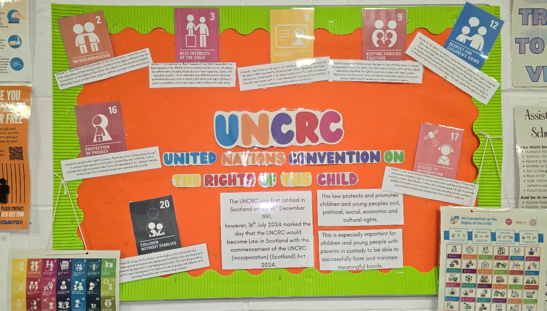

Impact and outcomes
- Following dialogue between the Visitors’ Centre Manager and prison senior management, the father’s children’s visits were reinstated, restoring his daughter’s right to contact.
- Prison management agreed to establish a joint working group to review past and future decisions to remove fathers from children’s visits due to substance misuse, with explicit consideration of child impact and UNCRC obligations.
- Prison Staff, with the support of Centre staff, are developing their understanding of tools that can be used to support their understanding of the impact on the child, such as the use of Child Impact Assessments.
- The display remains a permanent feature in the Visitors’ Centre, prompting ongoing questions from staff, families, and children.
- 13 other visitors’ centres and services across Scotland have also created their own displays and UNCRC material, contributed to by children and young people themselves to raise awareness.

Ongoing challenges
The father discussed in this study remains reluctant to participate in special events for fear that privileges could be withdrawn again, causing renewed trauma for his daughter and potential substance relapse for him.

“I would be heartbroken if my daughter thought she was coming to see Santa and me and this was taken away to punish me. I am worried about my release in February and if I will be able to be a good dad. I know it is wrong to use, but it helps with my anxiety sometimes.” Father

This example highlights the need for consistent decision-making that considers children’s rights, rather than discretionary or punitive responses.

Children’s human rights approach principles in practice
By using child designed tools, direct dialogue, promoting children’s rights, and persistent advocacy, Scotland’s Prison Visitors’ Centres are successfully encouraging the Scottish Prison Service to:
- Embed UNCRC considerations into policy and practice.
- Embed what is in the child’s best interest into service delivery.
- Treat the maintenance of parent and child relationships as a positive factor in rehabilitation.
Until comprehensive national training on the UNCRC is rolled out across the prison estate, the expertise and daily presence of Visitors’ Centre staff remain an invaluable bridge between prisons and the children whose rights the Scottish Government has committed to uphold.

