
Education Scotland: Youth Voice Toolkit

What was done
In August 2025, Education Scotland launched the Youth Voice Toolkit which aims to support a genuine approach to youth voice and consultation activities across schools and communities, organisations and local authorities.
The Youth Voice Toolkit builds on the original Social Justice Ambassadors Toolkit created by Stirling Youth Participation Team and young people involved in the Stirling Youth Forum. This work was developed and co-designed over time by practitioners and young people, alongside a whole council approach that was crucial to its success.
The Stirling Youth Participation Team supported us to develop the materials and scale up the approach into a regional model across Forth Valley and West Lothian. The regional Forth Valley and West Lothian Youth Voice Development Group continued to support the development of the toolkit through the creation of a regional Youth Voice Charter and a range of pilot projects.
This work ultimately resulted in the Toolkit as it is today, presenting a practical way to realise participation rights, underpinned by the Lundy Model of Participation and the Children’s Commissioner Seven Golden Rules of Participation. It is a tool for schools and Community Learning and Development settings, community organisations and local authorities to help make rights real for children and young people.
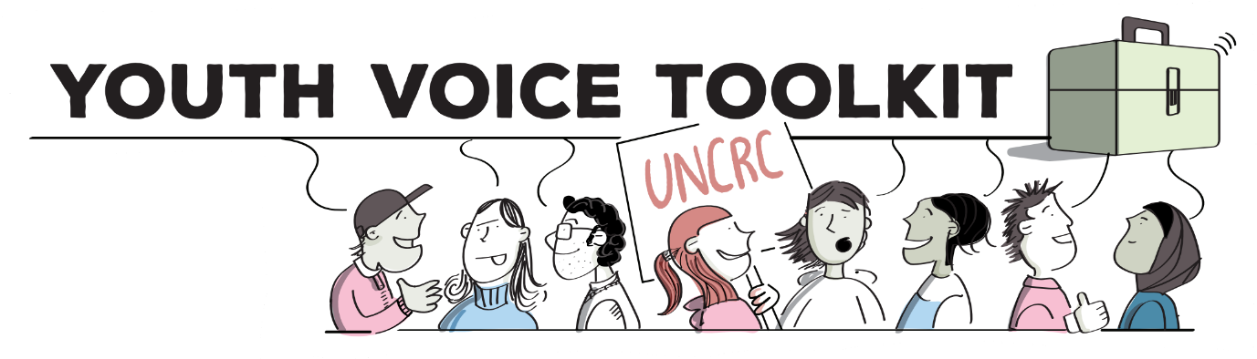
The Youth Voice toolkit contains implementation guidance, the Empowering Youth Voice Resource Pack and support materials to support practitioners and leaders to deliver a meaningful and non tokenistic approach to youth voice. The Toolkit can be used with existing youth voice structures such as pupil councils, youth forums and ambassador groups, or can used to support the development of new youth voice groups.
The toolkit responds to concerns raised by Together’s 2023 report which highlighted:
“Children continue to express frustration that their views are not listened to or taken seriously by decision makers. Key issues for children include tokenistic approaches, a lack of feedback loop, failure to include seldom heard groups – especially younger children, difficulties in accessing independent advocacy, and a sense that participation can sometimes feel forced/pressured rather than voluntary.”
It aims to address these challenges by providing practitioners with the methodology and tools to empower children and young people to lead on the ways in which their voices are heard and actioned.
To support a broader culture change around youth voice practice, encouraging a more representative, empowering and non-tokenistic approach, the Toolkit encourages all settings to do two central things.
The first is to create and embed a Youth Voice Charter. A Youth Voice Charter builds a mechanism to fully appreciate the ways in which children and young people wish to be consulted. The Toolkit gives guidance for practitioners on how to work with children and young people to create a charter of principles for effective youth participation. This forms a consistent, agreed and widely understood approach to consultation with children and young people – created by children and young people. This outlines the principles that all adults should follow when consulting with them.
The charter should consist of several statements and descriptive sentences that allow adults to understand the expectations on them when they seek to find out the views of children and young people. Forth Valley and West Lothian provide an example of a regional youth voice charter.
The second action is to facilitate peer research with the Empowering Youth Voices Resource Pack. The toolkit includes a downloadable Empowering Youth Voices resource to support children and young people within a youth voice structure to undertake peer-research on any theme or topic, supporting a more democratic and diverse process of consultation.
The pack upskills practitioners on how to empower children and young people to lead on peer research and represent the wider views on issues that affect their lives, across both school and community settings. The Toolkit has six sections that begin with learning about the importance of youth voice, children’s rights and UNCRC, before moving on to cover:
- Learning to work together as a group to represent their peers.
- Developing questions, undertake research and capture the views of their peers.
- Understanding key elements of research such as consultation, data and analysis.
- Creating an action plan following the results of the research.
- Presenting findings to leaders and decision makers.
The resource is a complete programme but does not need to be used prescriptively, it relies on practitioners using professional judgement and can be adapted to suit different settings.
This approach supports a consistent, genuine and non-tokenistic approach to youth voice, across a range of settings – facilitating a real way of implementing UNCRC participation rights. In addition, the toolkit approach provides a mechanism for peer-research to increase engagement and greater representation of diverse and collective views. There will be a Gaelic version of the resource launching online soon.
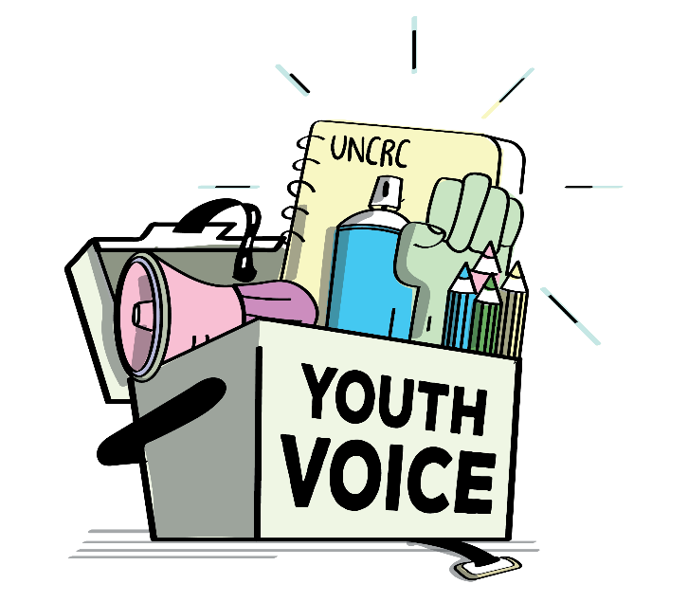

Impact and outcomes
Previous work in Forth Valley and West Lothian shaped how four local authorities initiated consistent youth voice processes, allowing a far greater representative group of children and young people to shape direction and influence decision makers.
Over 290 leaders and practitioners attended the launch event for the toolkit in August, with a further 60 attending two professional learning sessions in September. The Youth Voice Toolkit launch has had over 300 views on YouTube.
Regular professional learning sessions will continue to be facilitated by Education Scotland, offering practitioners space to learn about and discuss the Youth Voice Toolkit. A dedicated email address has been created for practitioners to feedback on the Toolkit and support impact measurement and future improvements.

Children’s human rights approach principles in practice
The overall aim for the Youth Voice Toolkit is to provide a mechanism for supporting a culture change in how children and young people are listened to, and taken seriously, across school and community settings. Further, the Toolkit supports a move away from tokenistic approaches to youth voice, going beyond day-to-day interactions, to create a more formal participation process of listening to children and young people and taking their views seriously.

